WEEK 3 DAY 4- OCT 22 (THURS)
Terminal:
node -v
npm -v
npm install -g react react-dom
practice-reactpractice-open terminal-to install: npm create vite@latest react-demo -- --template react- open in tegrated terminal in react demo subfolder
npm run dev
open package.json and see the components:
dependencies(during prod phase) and dev dependencies (req during dev phase)
oxlint-validates during the development time/phase
package-lock.json: lock different versions of packages and avoid conflicts
npm install(node package manager) equivalent to pip install
to update lock file : delete package-lock.json ---then go to terminal--- npm install----package-lock.json created (new file)
favicon.svg file: thunder icon
src subfolder: has all the source codes
assets subsubfolders: starting resources (pictures etc), app.css: all style sheets at rootlevel, app.jsx: rootcomponent of app it gets rendered in the UI, index.css: css applied to the index file(core global settings things like font of entire website with fallbacks etc), main.jsx: entry point of a java application/it’s a method
oxlinting-standards to be followed as part of java script
index.html- root html page of this app
vite.config.js file: vite is the extension which helps to build this structure
components in app.jsx:
function components and react component
parameter is called name property here
dynamic compilation def
“Product” is a functional component
“App” is the other component
Component driven architecture
In app.jsx, code:
function Product(props) {
return (
<div>
<h2>{props.name}</h2>
<p> price: rs.{props.price}</p>
<p> discount: rs.{props.discount}</p>
</div>
)
}
function App() {
return (
<div>
<h1> product list</h1>
<Product name = "mouse" price = "1200" discount = "20"/>
<Product name = "laptop" price = "2200" discount = "20"/>
<Product name = "keyboard" price = "3200" discount = "20"/>
</div>

)
}
export default App
new file- Product.jsx and make modifications in this code:
Product.jsx, code:
function Product(props) {
return (
<div>
<h2>{props.name}</h2>
<p> price: rs.{props.price}</p>
<p> discount: rs.{props.discount}</p>
</div>
)
}
export default Product

App.jsx, code:
import Product from "./Product"
function App() {
return (
<div>
<h1> product list</h1>
<Product name = "mouse" price = "1200" discount = "20"/>
<Product name = "laptop" price = "2200" discount = "20"/>
<Product name = "keyboard" price = "3200" discount = "20"/>
</div>

)
}
export default App
added a button to product.jsx:
anonymous method?
Usestate maintains the variable in the main page(add to cart quantities)--Use the function to act on the variable (eg: increasing the variable by 1)
Code:
import { useState } from "react"

function Product(props) {
const [count, setCount] = useState(0) // variable and a function

return (
<div>
<h2>{props.name}</h2>
<p>Price: ₹{props.price}</p>

<button onClick={() => setCount(count + 1)}>
Add to Cart
</button>

<p>Quantity: {count}</p>
</div>
)
}
export default Product
output:
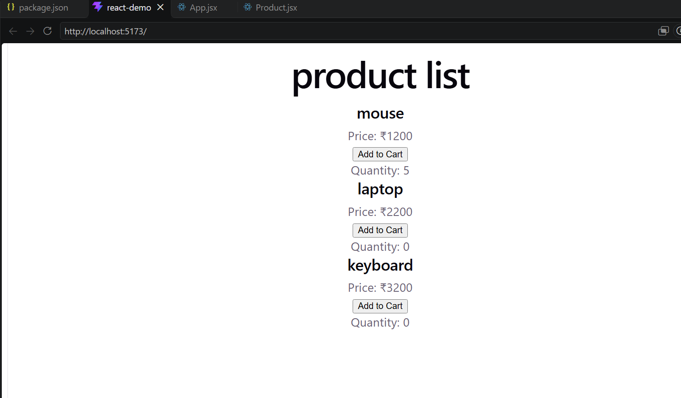
POST 11am BREAK:
Modified App.jsx code:
import Product from "./Product"

function App() {
const products = [
{ id: 1, name: "Wireless Mouse", price: 1200 },
{ id: 2, name: "Keyboard", price: 2500 },
{ id: 3, name: "Monitor", price: 12000 }
]

return (
<div>
<h1>Product List</h1>

{products.map((product) => (
<Product
key={product.id}
name={product.name}
price={product.price}
/>
))}
</div>
)
}

export default App
more modifications: https://codeshare.io/G8WnyZ to add text fields -see demo
app.jsx code:
import { useState } from "react"
import Product from "./Product"

function App() {

const [products, setProducts] = useState([
{ id: 1, name: "Wireless Mouse", price: 1200 },
{ id: 2, name: "Keyboard", price: 2500 },
{ id: 3, name: "Monitor", price: 12000 }
])

const [name, setName] = useState("")
const [price, setPrice] = useState("")

function addProduct() {
const newProduct = {
id: products.length + 1,
name: name,
price: price
}

setProducts([...products, newProduct])

setName("")
setPrice("")
}

return (
<div>
<h1>Product List</h1>

<input
type="text"
placeholder="Product name"
value={name}
onChange={(e) => setName(e.target.value)}
/>

<input
type="number"
placeholder="Price"
value={price}
onChange={(e) => setPrice(e.target.value)}
/>

<button onClick={addProduct}>
Add Product
</button>

{products.map((product) => (
<Product
key={product.id}
name={product.name}
price={product.price}
/>
))}
</div>
)
}

export default App
output:
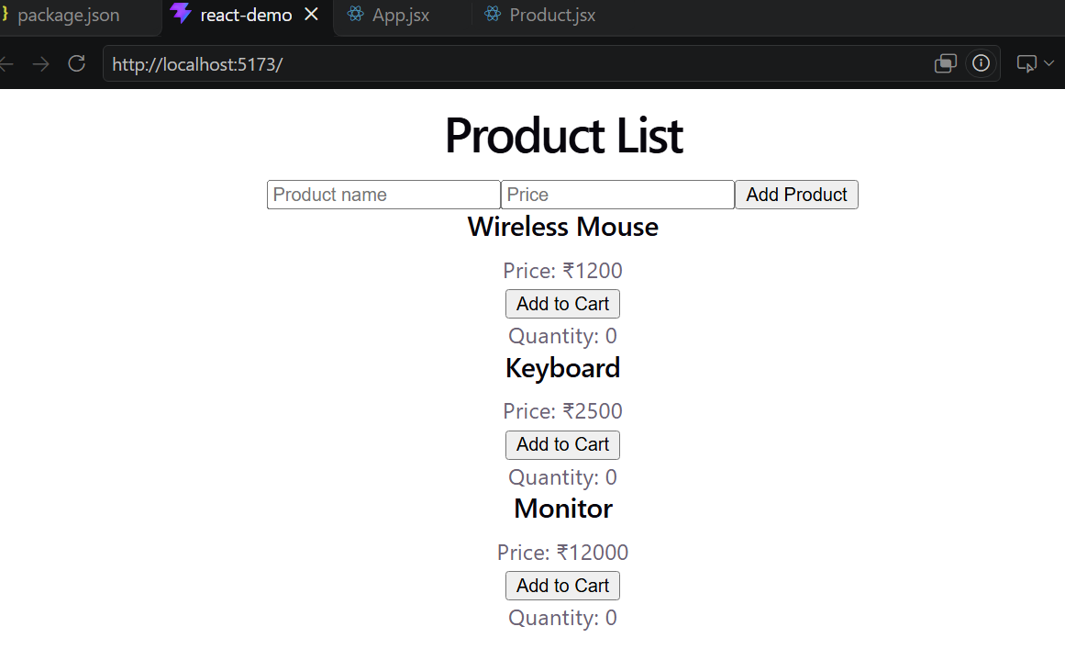

More mofifications to app.jsx:
import { useState } from "react"
import Product from "./Product"

function App() {
const [products, setProducts] = useState([
{ id: 1, name: "Wireless Mouse", price: 1200 },
{ id: 2, name: "Keyboard", price: 2500 }
])

const [name, setName] = useState("")
const [price, setPrice] = useState("")

function addProduct(event) {
event.preventDefault()

const newProduct = {
id: products.length + 1,
name: name,
price: price
}

setProducts([...products, newProduct])

setName("")
setPrice("")
}

return (
<div>
<h1>Product List</h1>

<form onSubmit={addProduct}>

<input
type="text"
placeholder="Product name"
value={name}
onChange={(e) => setName(e.target.value)}
/>

<input
type="number"
placeholder="Price"
value={price}
onChange={(e) => setPrice(e.target.value)}
/>

<button type="submit">
Add Product
</button>

</form>

{products.map((product) => (
<Product
key={product.id}
name={product.name}
price={product.price}
/>
))}

</div>
)
}

export default App
output:
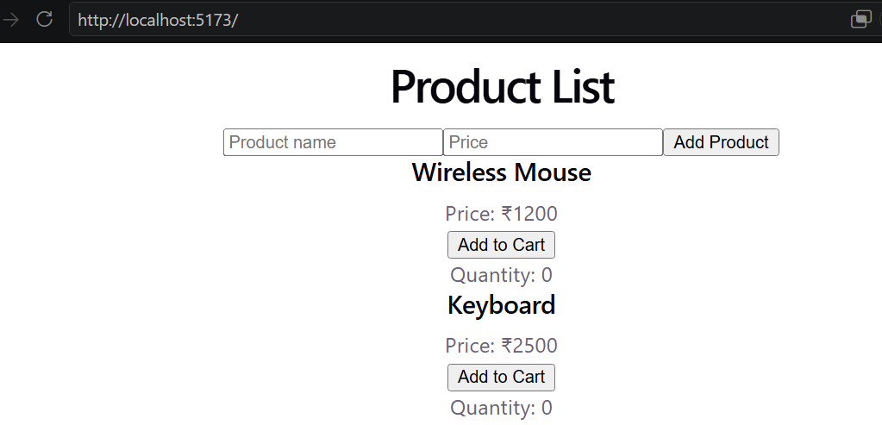
CREATING FASTAPI IN PYCHARM:
http://127.0.0.1:8000/products
uvicorn main:app --reload
check ui
ASSIGNMENT: https://drive.google.com/file/d/1BCnKCFDaCMonlvXa7r1BP6fX9-p7beTG/view?usp=sharing -separate files in the folder
CORS(post break)
Cross origin resource sharing (CORS)
Domain: example.com(react project should be allowed) will try to access resources of contonso.com(img,pdf,policy docs, project details)---default behaviour would be “not allowed”, CORS enables it to be “allowed”
Pycharm
In file main.py, look at app.middleware portion
Whitelist it , ow it will throw cors error
- Application layer
- Middlewarre layer-api request
- Backend

